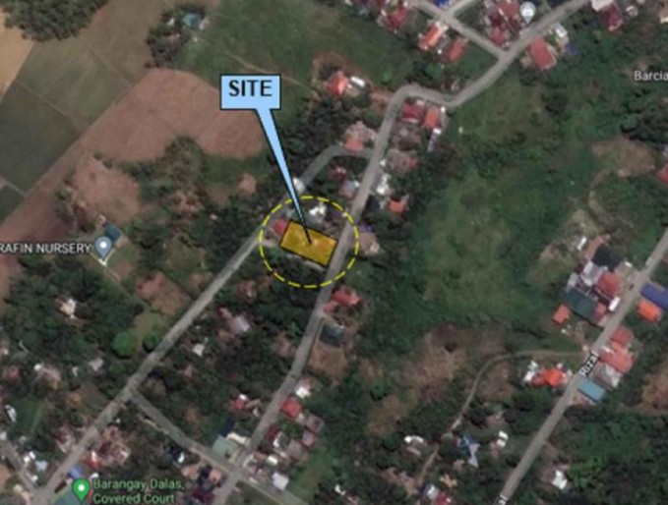
Property II – Lot No. 1
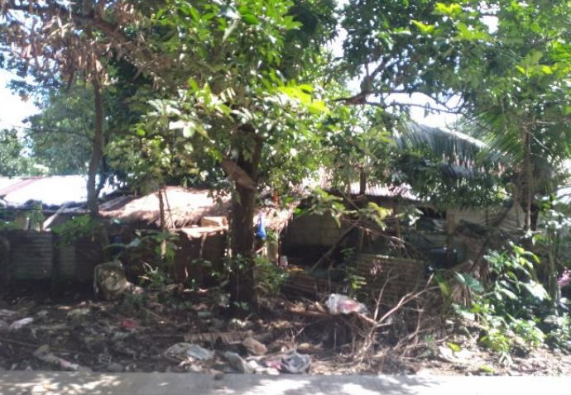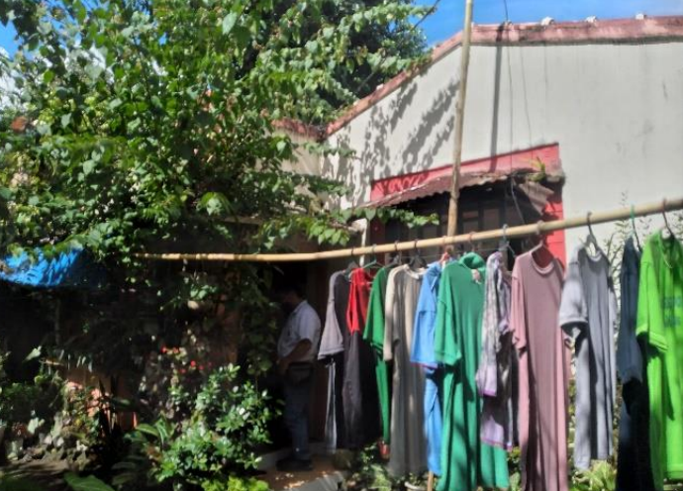
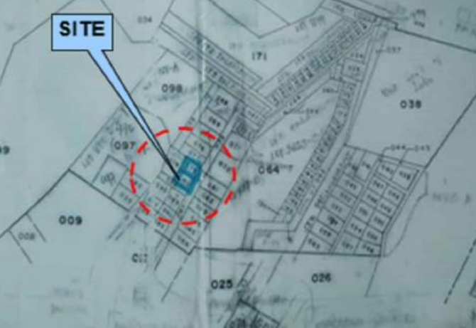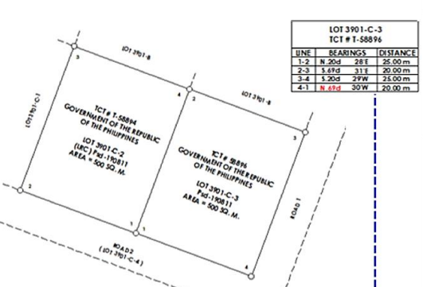

Asset Name : Peninsula Development Bank
TCT Nos. : T-58896 and T-58894
Area : 1,000 square meters
Location : Brgy. Dalas, Labo, Camarines Norte

